Additional BJT Circuits HW (25 points)
(jas, Additional BJT Circuits HW.docx, 7/26/2025)

Clearly indicate answers and include units for numeric answers, using 3 or 4 significant figures. Show at least the major steps of your work so that if necessary partial credit can be awarded.
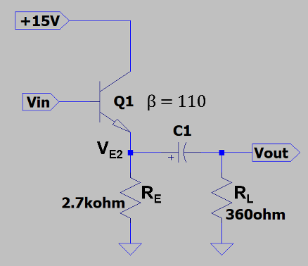
- Determine the following values for the adjacent common-collector (emitter-follower) circuit with a dc bias voltage of 6.1 V at V_{in}. (Hint: A_{V} should be somewhere between 0.95 and 0.99.) (8 points total.)

- r_{e1} (2 Points.)
$$r_{e}=R_{E}∥R_{L}=2.7kΩ∥360Ω=317.6Ω$$
$$r_{e}=317.5Ω$$

- $r_{e1}^{'}$ (2 Points.)
$$r_{e}^{'}=\frac{25mV}{I_{E}}$$
$$I_{E}=\frac{V_{in}-0.7V}{R_{E}}=\frac{6.1-0.7V}{2.7kΩ}=2.0mA$$
$$r_{e}^{'}=\frac{25mV}{2.0mA}=12.5Ω$$
$$r_{e}^{'}=12.5Ω$$

- Z_{in} (2 Points.)
$$Z_{in\left(base\right)}=β\left(r_{e}+r_{e}^{'}\right)=110\left(317.6Ω+12.5Ω\right)=36316Ω=36.3kΩ$$
$$Z_{in\left(base\right)}=36.3kΩ$$

- A_{V} (2 Points.)
$$A_{v}=\frac{r_{e}}{r_{e}+r_{e}^{'}}=\frac{110}{317.6Ω+12.5Ω}=0.962$$
$$A_{v}=0.962$$

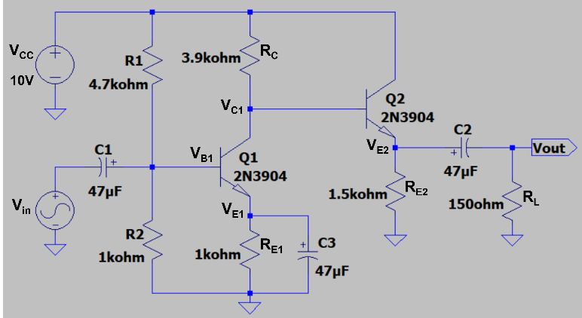
- Determine the following values for the adjacent cascaded common-emitter and common-collector (emitter follower) amplifier circuit, given the voltage gain of -144 for the common-emitter stage with voltage V_{C1} = 5.9 V. (Hint: The magnitude of A_{V_Total} should be between 132 and 142.) Be sure to include units in your answers. (8 points total.)

- $r_{e2}$. (2 Points.)
$$r_{e2}=R_{E2}∥R_{L}=\frac{1.5kΩ*150Ω}{1.5kΩ+150Ω}=136.36Ω$$
$$r_{e2}=136.36 Ω$$

- $r_{e2}^{'}$. (2 Points.)
$$r_{e2}^{'}=\frac{25mV}{3.47mA}=7.21Ω$$
$$r_{e}^{'}=7.21Ω$$
- Voltage gain of the common-collector (emitter follower) stage A_{VCC.} (2 Points.)
$$A_{VCC}=\frac{r_{e}}{r_{e}+r_{e}^{'}}=\frac{136.36}{136.36+7.21}=0.9498$$
$$A_{VCC}=0.9498$$

- Overall voltage gain A_{V_Total.} (2 Points.)
$$A_{V_{Total}}=\left(-144\right)\left(0.9498\right)=-136.77$$
$$A_{V_Total }=-136.77$$

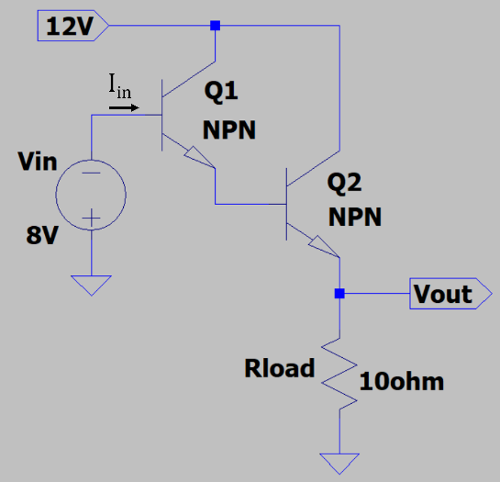
- For the adjacent Darlington circuit, determine the current I_{in}, given β = 120 for both Q1 and Q2.
(2 points.)
$$V_{B1}=-8 V$$
$$V_{B2}=V_{B1}-0.7 V$$
$$V_{out}=V_{B1}-1.4 V$$
$$I_{Rload}=\frac{V_{out}}{Rload}$$
$$I_{C2}=β_{2}I_{B2}=I_{Rload}$$
$$I_{B2}=I_{E1}≈I_{C1}$$
$$I_{C1}=β_{1}I_{B1}$$
$$I_{B1}=\frac{I_{C1}}{β_{1}}$$
$$V_{B2}=-8.7 V$$
$$V_{out}= -9.4 V$$
$$I_{Rload}=-\frac{9.4V}{10Ω}=-0.94 A$$
$$-0.94 A=120*I_{B2}$$
$$I_{B2}=-0.0078 A= -7.8mA$$
$$I_{E1}≈I_{C1}=-7.8mA \\ -7.8 mA=120*I_{B1}$$
$$I_{B1}= -65.28 μA=I_{in}$$
$$I_{in}=-65.28 μA$$

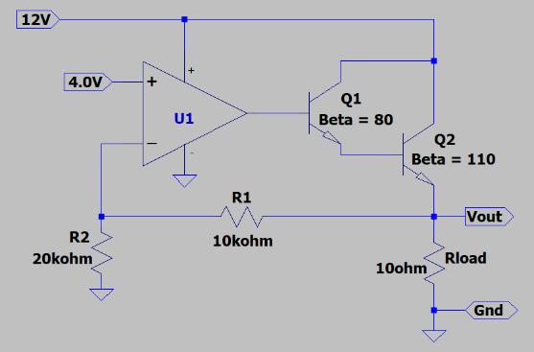
- Calculate the following values for the adjacent voltage regulator circuit with a 10 Ω load. (Hint: The output current of op-amp U1 is between 65 and 75 µA.) (7 points total.)

- V_{out}. Document your work so that others can follow your method, including assumptions along with at least 2 steps involved in arriving at V_{out}. A correct answer without any work shown and/or mention of assumptions will only receive 1 out of 3 points. (3 points.)
$$V_{p}=V_{n}=V_{R2}=4.0 V$$
$$I_{R2}=I_{R1}=\frac{4.0V}{20kΩ}=0.2 mA$$
$$V_{R1}=I_{R1}*R1=2V$$
$$V_{out}=V_{R1}+V_{R2}=2V+4V=6V$$
$$V_{out}=6V$$

- I_{Rload}. (2 points.)
$$I_{Rload}=\frac{V_{out}}{R_{load}}=0.6A$$
$$I_{Rload}=0.6A$$
- I_{out} of op-amp U1. (2 points.)
$$I_{C2}≈I_{E2}=I_{Rload}+I_{R1}=600.2 mA$$
$$I_{B2}=\frac{I_{C2}}{β_{2}}=5.456 mA$$
$$I_{C1}≈I_{E1}=I_{B2}=5.456 mA$$
$$I_{outU1}=I_{B1}=\frac{I_{C1}}{β_{1}}=68.201 μA$$
$$I_{outU1}=68.201 μA$$

